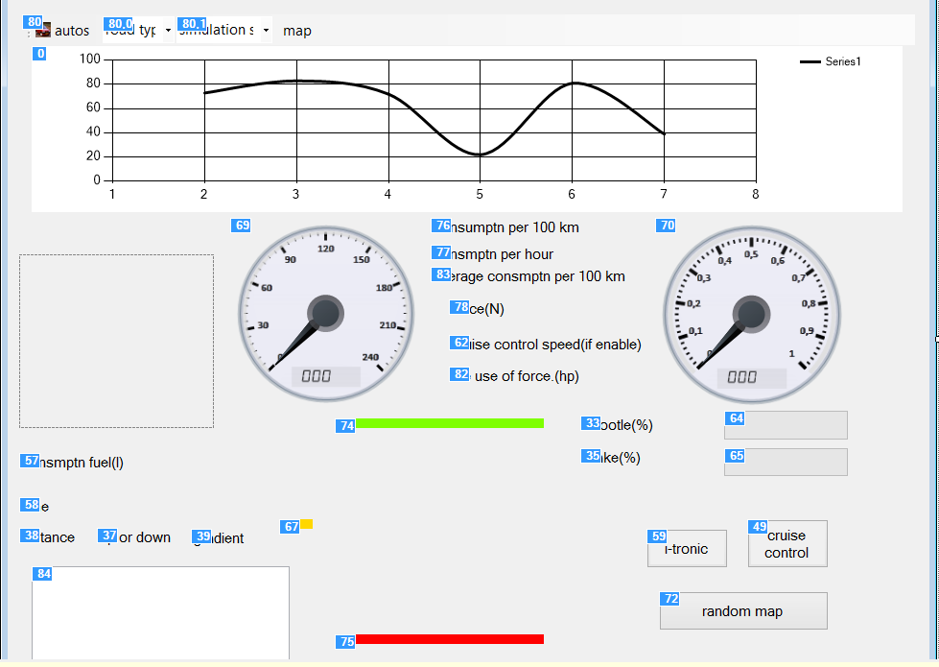
80> components of the vehicle is selected, this tab is selected through the car, and as soon as the selected timer is activated, the program starts streaming.
80.0> Selection of contact with the road surface forming the vehicle,
80.1> Selecting the simulation speed multiplier.
0> According to the distance the vehicle gets symbolize the climb and descent and scale graphics.
69> vehicle speed digital and analog displays, in the middle indicates the received total road in km.
76> The tool instantly predicts the fuel consumed per 100 km.
77> Instantly shows the amount of fuel the vehicle consumes per hour.
83> Average fuel consumption is realized.
78> traction force of the vehicle.
62> If cruise control is active, it shows the fixed speed.
82> Characterize the power consumption by the use of the vehicle.
70> Rpm in analog and digital, are indicated in the middle of the gear indicator.
57> Realized shows the total fuel consumption in liters.
58> The tool shows the running time since the election.
38> remaining travel.(*)
37> define a road is gradient up or down..(*)
39> road is how much gradient value.(*)
64> how much is driver pressing a throttle?.
65> how much is it brake percent.
67> It specifies the accelerator and brake threshold. If the cursor is in this field, as if pulled down red proportional brake, the throttle is pulled upward in proportion to the green.
74> It indicates the vehicle's acceler- ator line..(**)
75> It indicates the brake line..(**)
33,35>64 and 65 'which is described labeled substances.
84> The car's gear is the enhancing elements that form the data kept in the list. Here hopping transmission process takes place, respectively, switching gear, rpm, speed, stored data before transmission.
59>84 held data of the vehicle to be pressed gear trained himself by this key if the user is provided externally if gear is disengaged mode hopping process is done in the form element 84 is cleaned, re-start storing data.***)
49> If pressed this button will accept the rate fixed vehicle speed at that moment and it does not give the speed of the vehicle if gas on if it tries to maintain its speed drops below the speed by gas. If the cursor again brought to the brake or gas from the field will be automatically mode. (****)
81> If the map has changed or if the selection process takes place automatically from the database of the way that the data will be taken in cycles, respectively. If you have or if you have selected map takes place in this key is pressed to the road map selection is disabled and the data of the limits laid randomly.
(*)The values in the generated source code is shown with fixed values.
(**)Mouse green, it is recommended to provide the exact test is given by the calibration gas and the gas and brake, the brake function between yellow and red lines in a healthy way in which part of the screen before selecting a tool to fulfill. (Otherwise the program will not work correctly..)
(***)Gear hopping process with the left mouse click into top gear, switching to lower gear is provided with a right click. In addition, i-tronic gear entangled as a homogeneous whole shift of the car to work healthy and stable data transmission hopping i-tronic system will provide a more stable operation.
(****)(**) It shall also be made at the discretion of the cruise that best screen calibration as mentioned negatively affect proper operation.

